RESUME DATA ANALYSIS REPORT

INTRODUCTION:

This project focuses on analysing and understanding resume data to identify the most frequent skills and aptitudes in each job category.
The ultimate objective is to help recruiters identify candidate potential and prepare data for a predictive model that can automatically classify resumes or detect hidden skill aptitudes (e.g., people from agriculture showing management potential).

TOOLS & TECHNOLOGIES:
STAGE | TOOL/LIBRARY
ENIRONMENT | GOOGLE COLLAB
DATA HANDLING | PANDAS,NUMPY
TEXT CLEANING AND NLP | REGEX,NLTK,SPACY
VISUALIZATION | MATPLOTLIB,SEABORN
MACHINE LEARNING PREPARATION | SCIKIT LEARN

DATASET DESCRIPTION:
- Dataset name: cleaned_resume.csv
- Records: approximately 2400 resumes
- Fields:
ID: unique identifier for each resume
Category: job type (IT, HR, Agriculture, Finance, etc.)
Resume Text: full resume text extracted from PDFs
Clean Text processed version after cleaning
Each record represents one candidate’s resume and it’s labelled job category.

DATA PREPROCESSING:

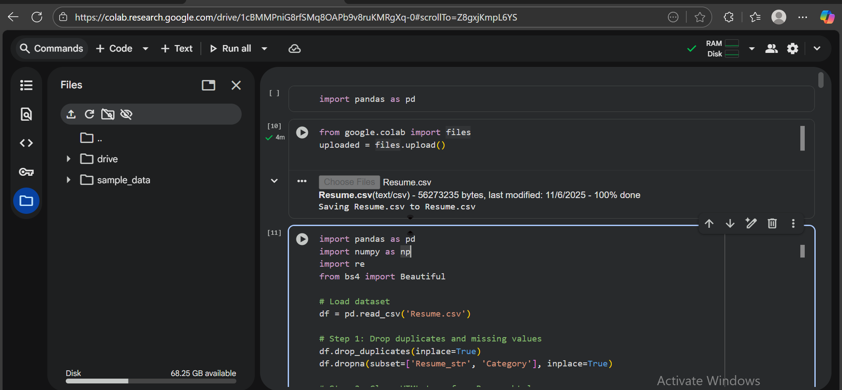

TEXT CLEANING:

STEP | Method | Purpose
Lowercasing | text.lower() | Normalize case
Removing punctuation & special symbols | Regex [^\w\s] | Clean the text
Stop word removal | nltk.corpus.stopwords | Keep only meaningful words
Lemmatization | spaCy nlp() pipeline | Convert words to their base form
Tokenization | word tokenize() | Split into individual words
Join cleaned tokens | ' '.join(tokens) | Create cleaned text string

Example Result:
Before cleaning:
“Responsible for developing and maintaining websites, with strong communication skills.”
After cleaning:
“develop maintain website strong communication skill”

Feature Extraction:

Skill Extraction
A custom skill dictionary (approximately 200 entries) was created manually based on job domains (HR, IT, Agriculture, Sales, etc.).
Example skills:
['python', 'management', 'excel', 'sales', 'crop management', 'recruitment', 'finance']
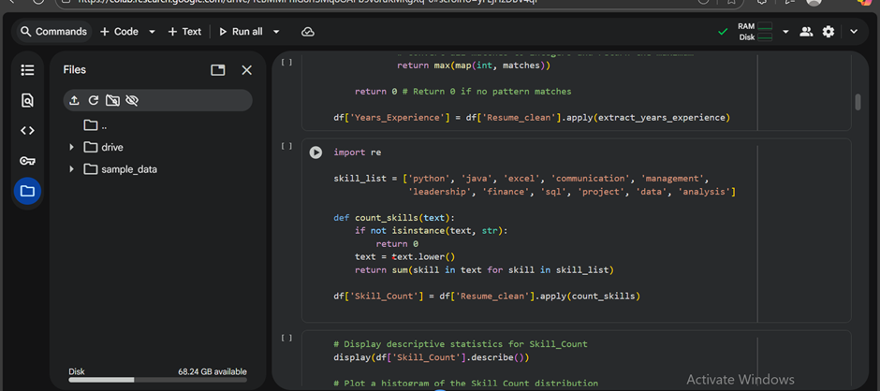
Used Regex and word-boundary matching to detect these in resumes:

Encoding and Feature Creation:
Built all visualizations directly in Colab using Matplotlib and Seaborn.

Chart | Purpose
Bar Plot | Top 10 skills / category
Word Cloud | Common words in resumes
Box Plot | Outliers in years of experience
Scatter Plot | Skill count vs experience
Pie Chart | Resume distribution by category

NB:
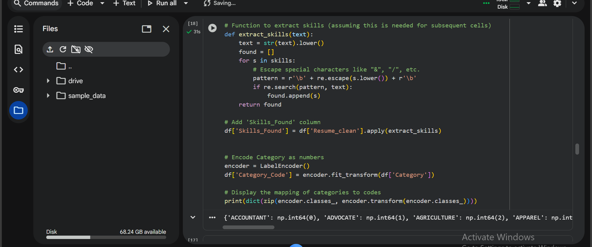
Outliers in Years’ Experience and Skill Count were checked using IQR.

Skill Frequency per Category:
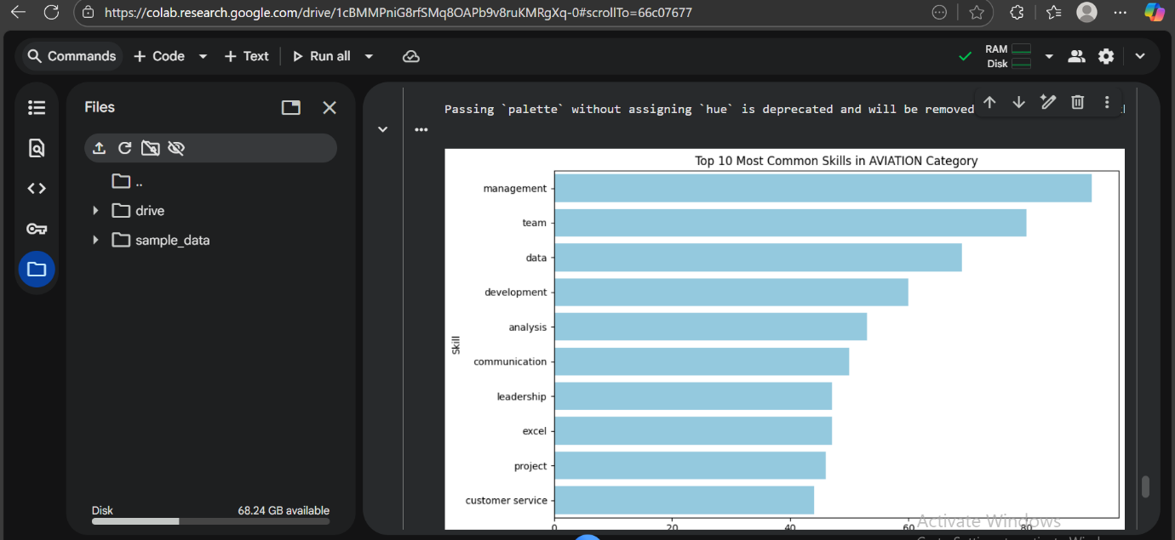
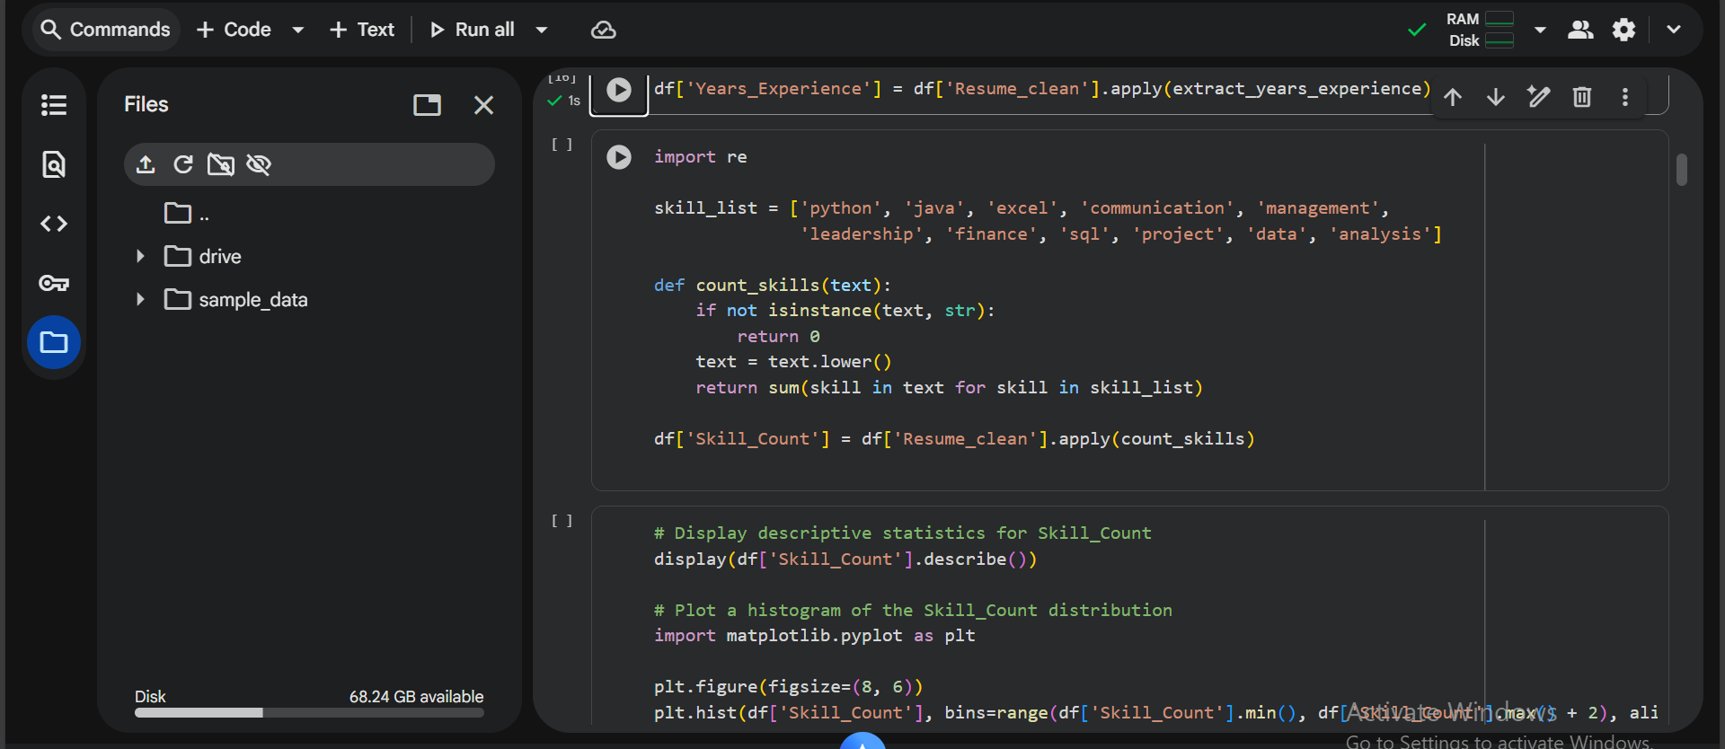

Key Insights:
- Management and communication skills appear frequently across multiple non-management domains.
- IT resumes heavily emphasize Python, SQL, and Web Development.
- HR, Business, and Sales emphasize soft skills like communication, leadership, and negotiation.
- Cross-domain skills (like project management) appear in unexpected categories.

Conclusion:
The project successfully demonstrates how natural language processing can extract structured information from unstructured resumes.
By identifying top skills and computing experience, this analysis builds the foundation for an intelligent resume-classification system to assist recruiters in candidate screening and skill-matching.

